
Welcome to the Fresh Start 30-Day Sugar Reset!

Congrats! You have taken the first step towards a healthier you by committing to this 30-Day Sugar Challenge! The four purposes of this challenge are to:
- Reset your metabolism
- Stabilize your blood sugar
- Increase awareness of the amount of sugar you consume daily
- Learn how to recognize added sugar when reading food labels

Over the next 30 days you will receive:
- Weekly emails and challenges
- Recipes
- Visual guides
- Encouragement and community support (join our Facebook SPH Challenge group)

Time to get ready! Go through your fridge, freezer, and pantry and set aside anything with added sugar in the ingredient list.
Plan a few meals and no-added sugar snacks like fruit, vegetables, mixed nuts and cheese to your shopping list to enjoy when the sweet cravings hit.
Shop before the challenge starts. Give yourself extra time at the grocery store to take time to look at nutrition labels and ingredients. Added sugar is prominent in about 75% of the grocery store, so spend some time looking at not only the food label, but also the ingredient list. Remember this challenge includes not eating or drinking anything sweet that is added to food including natural sugars such as agave, honey, maple syrup, or sugar alternatives like stevia or monk fruit.
Prep your meals and snacks. You may have brain fog, headaches and fatigue the first few days of this challenge, so taking time the day before the challenge to wash, chop and prepare your fruit and veggies for snacks and meals will take the guesswork out of what you can eat when you may be feeling tired.

Read all food labels. Added sugar and sweetener is not the easiest to locate. There is one definitive place to look when you're buying food - the food label. Look to the food label and you'll find info in the ingredient list and also the added sugar list. The label may not list any added sugars, but be sure to read the ingredients. If a form of sugar is listed, it’s not recommended in this challenge.

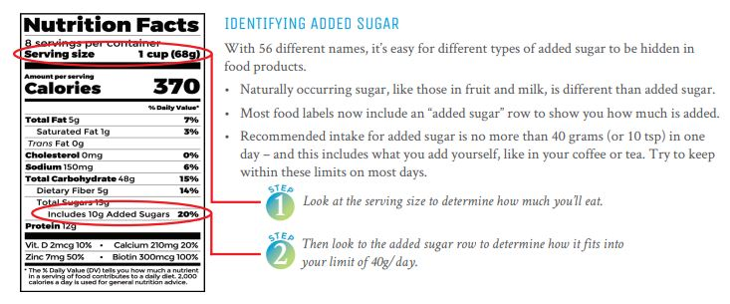

Ingredients to watch out for: Sugar alcohols- words ending in "-'ol" (i.e. erythritol, mannitol, sorbitol, etc.), anything “sugar free” (stevia, sucralose, saccharin and aspartame), and processed sugars like brown rice syrup, corn syrup/ high fructose corn syrup.

The goal of this challenge: To help adjust your sugar consumption to the recommended amount. Throughout this challenge your brain might tell you to consume sugar because you feel better when you do. Even if you cannot be entirely free from it for 3 weeks, you are still helping your body to detox. Slip-ups happen, cravings happen, sometimes parties and dinner dates happen. If you have some sugar, do not give up, just do your best! Do not diet or restrict calories during this challenge. This challenge will encourage healthy eating habits that you can maintain moving forward.
This challenge is about a refrain, reset, and recharge. It isn’t going to be easy but it will be worth it. Remember, you are not alone in this! This will be an awesome challenge, you’ll learn a lot, and by the end of the challenge you will feel a major difference!

